14

Portfolio Guide
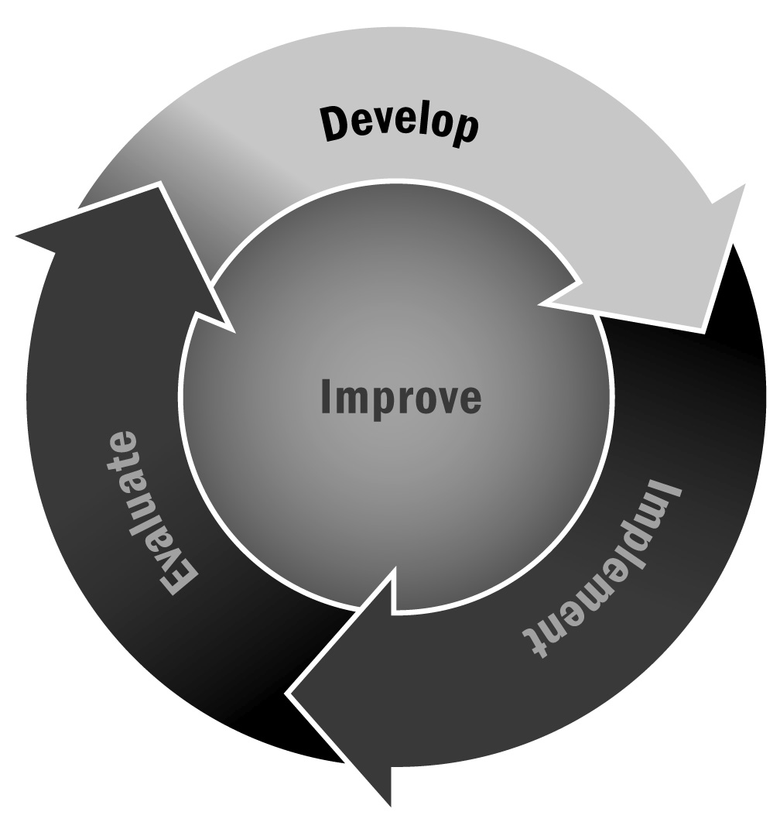
Creating a portfolio is a collaborative process that can be a great way for program staff members and youth to document their experience in the program. The primary purpose of a portfolio is to allow a young person to showcase his or her program experiences and successes and to enable program staff members to monitor and support youth by understanding their work, their interests, and their lives outside of the program. Young people should be the primary drivers of constructing their portfolios, and the process should help to develop bonds between youth and staff.
Directions: This tool suggests a variety of information that you might want to include in youth portfolios. You can easily start with basic demographic information gathered at enrollment and then add more over time. Youth and program staff members should update portfolios with notes regarding participant accomplishments, areas of interest, participant and family surveys, interest inventories, and other work products described below. You may not want or be able to collect all the information right away; youth and staff members should actively gather information for different sections of the portfolio over time.
Creating a portfolio should be a joint effort between the young person and staff members. There is no “correct” format for a portfolio. You may just have manila folders or binders that you add to over the course of the year with photos, printouts, report cards, reflections, surveys, and other materials. Alternatively, you may have something more extensive and organized that includes different sections and that formally captures data; it could even be electronic. The format you choose will depend on how much time you have to dedicate to this and how you anticipate using the portfolio throughout the year. Whatever your format, remember that your portfolios contain a great deal of confidential information and that they should be kept in a safe place, preferably in a locked drawer or a password-protected file on a computer.

Basic Information
You should capture basic demographic information at enrollment. You can include your enrollment form in the folder or transfer it onto a separate form. If you use an online participant tracking system, you may be able to print out a demographic information sheet to include in the portfolio. Include, at a minimum, the following information:
- Participant name
- Date of birth
- Gender
- Languages spoken, including primary home language
- School name
- Year/grade level
- Years in the program
- Reasons for attending the program (Interest? Family members? How did you hear about the program? Do you have friends in the program?)

Youth Interest Information
You likely use youth surveys to capture information about youth in your program. Surveys may ask questions about their interests as well as their social and emotional, academic, and physical well-being. Keep survey results in your youth portfolios. It is best to transfer the answers to key survey questions onto a separate page or form rather than just including the survey itself in the portfolio. In addition to (or instead of) surveys, you may have your staff members interview or talk with youth one on one or in small groups to get the information you need. Participants can also do a project that reflects their interests (such as self-portraits with magazine clippings that represent their interests). Collecting participants’ reflections is also a great way to capture youth assets and interests. Staff members should reference this section during planning time to develop specific strategies and support youth interests. Some topics to include in your portfolios include:
- Favorite school class/subject (Why?)
- Least favorite school class/subject (Why?)
- What you look for in adult leaders (Why?)
- Sports or extracurricular activities (e.g., school, park district, club team)
- Career aspirations (What type of job/career would you like to have in the future? What are you interested in? Do you know what it takes to get that type of job/career?)
- Postsecondary aspirations (What college would you like to attend? Do you know where that is located/what its entry requirements are?)
- Favorite afterschool activities (at this program) and suggestions for or interest in new programs
- Reasons you like the program
- Reasons you do not like the program

Youth Asset Inventory
Each participant brings his or her own contribution to the afterschool and expanded learning setting through his or her unique and individual characteristics. This information is more difficult to capture and collect. Decide with your group and with each participant how to best capture this information. We have outlined some ideas here, but it is best to be creative and let young people drive the process. Information recorded here should extend beyond the basic data collected during enrollment. You can collect it through project work throughout the year, conferences with family members, talking with youth directly, conversations with school faculty and administrators, and observation and note-taking. Below are examples of information that could be gathered and that should be updated regularly.
- Learning style (e.g., school grades/courses, learning ability, visual learner) – This can be gathered through school-related data, talking with school day teachers, observation by instructors in the afterschool and expanded learning program, and conversations with family members.
- Social observations (e.g., introvert, popular, social group, cliques) – This can be gathered through circle time conversations with youth, reflections on social situations and role play, observations, talking with school day teachers, talking with youth one on one, talking with family members, and through surveys with relevant questions.
- Emotional competencies (e.g., assertive, empathetic) – This can be gathered through conversations with youth and conversations with their school day teachers and other adults in the young person’s life, as well through observations.
- Character observations (e.g., leadership, confidence, problem solving) – This can be gathered through conversations with youth and with their school day teachers and other adults in the young person’s life, as well through observations.
- Skills and interests (e.g., sports, art, theater, independent learning) – This can be gathered through an inventory of programs in which the young person has participated, as well as youth surveys.
- Other relevant information (e.g., behavior) – This can be gathered through observation, youth surveys, and talking with teachers and other adults in the young person’s life.
- Reflections from youth on all of the above.

Program Participation
Youth are more likely to experience the benefits of the afterschool and expanded learning program if they participate consistently in a variety of activities. Program staff members should incorporate participants’ interests to ensure that they actively engage in program activities and projects. The following list suggests information that could be included in this section:
- School attendance and grades (self-reported, report card, test scores)
- Program participation data (average days of program attendance per week, per month, per year; types of activities youth are participating in)
- Challenges to participation or attendance (e.g., babysitting younger siblings, jobs, sports)
- Results from satisfaction surveys (e.g., satisfaction with activities and topics)
- Notes from conversations, observations, and discussions about attendance
- Notes from formal meetings or discussions with a school teacher, tutor, or counselor related to the participant’s attendance
- Notes from formal meetings or discussions with family related to the participant’s attendance
- Reflections from youth on all of the above

Youth Work
It is important to capture a snapshot of a young person’s passion in school and in other aspects of his or her life and the growth of his or her work over time. In this portion of the portfolio, you can capture young people’s favorite work products and the type of work they are doing at the beginning and end of the program. You can use work products as a way to inform family members about growth, celebrate success, and plan for additional supports. Types of work to capture in this section include:
- Academic work (e.g., homework sheets, handwriting work, math problems)
- Art work (e.g., drawings, photographs of sculptures or stage performances, musical recordings, etc.)
- Project work (e.g., artifacts from service learning projects, pages from a youth-designed newspaper, posters from a public service campaign, etc.)
- Reflections from youth on all of the above

Community Context
Staff members should play close attention to the resources and characteristics of the local and school community where youth live and develop. Young people and staff members should gather information for this section from various sources to discuss everyday issues that may affect the life of a participant. Staff members can also gather information for this section from the asset mapping activity (Tool 34). Examples of information that could be gathered include the following:
- Local assets frequented by participants (e.g., park, recreation center)
- Critical information about the participants’ community (e.g., local news)
- Local neighborhood issues/areas of concern (e.g., violence, poverty, unemployment)
- Youth comments (notes from conversations, products from service learning projects, observations, and discussions with the program participant about his or her friends, school, neighborhood, program, or household issues)
- Classroom teachers’ comments (notes from formal meetings or discussions related to the program participants’ neighborhood or household circumstances)
- Family comments (notes from formal meetings or discussions related to the program participants’ school, neighborhood, or household circumstances)
- Reflections from youth on all of the above

