63

Youth Development Checklist
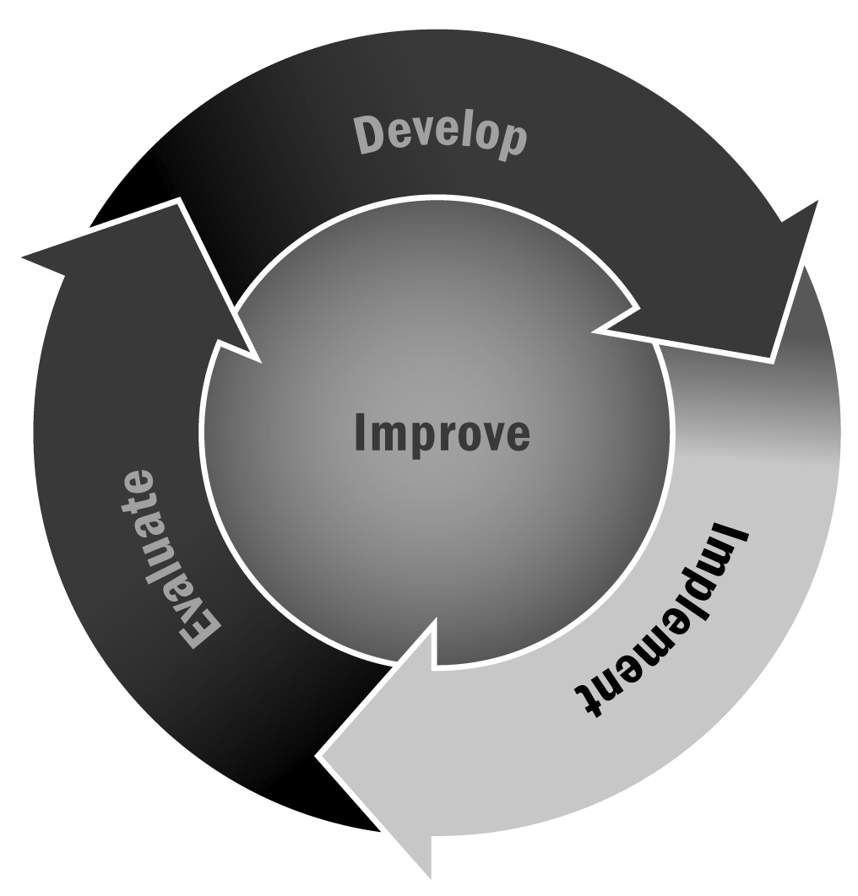
Youth development refers to various means of fostering positive growth in youth, building on their strengths, and addressing their developmental needs. You can use this checklist to gain an overall view of how your entire program is incorporating youth development principles and practices.
Directions: Read the following list of youth development principles and practices and then indicate how well you think your program is addressing each one. When you have finished, review your checkmarks to determine the areas that appear strong and the areas that could be improved. This checklist can be completed and reviewed individually or discussed as a group.
Youth Development Checklist
 | Yes | In Process |  | No
Warm and Welcoming Environment
Procedures are in place to ensure young people’s safety (e.g., emergencies, security). | ❒ | ❒ | ❒
Adult supervision is provided at all times. | ❒ | ❒ | ❒
Emergency and contact information is available for all youth. | ❒ | ❒ | ❒
Healthy eating and physical activity are promoted. | ❒ | ❒ | ❒
Healthy snacks are offered daily. | ❒ | ❒ | ❒
The program’s hours of operation are based on families’ schedules. | ❒ | ❒ | ❒
Cultural and linguistic differences are respected. | ❒ | ❒ | ❒
The program or activity has a name that youth can identify. | ❒ | ❒ | ❒
Youth are respected for their individuality. | ❒ | ❒ | ❒
Programs are available for all youth who want to participate. | ❒ | ❒ | ❒
Support for Positive Behavior
Youth understand the expectations of the program. | ❒ | ❒ | ❒
Staff members regularly offer sincere praise with specific comments and feedback for positive behavior. | ❒ | ❒ | ❒
Youth participate in setting program or activity rules. | ❒ | ❒ | ❒
Rules are clear, consistent, and fair. | ❒ | ❒ | ❒
Rules address cooperating, sharing, caring for materials, participation, behavior strategies, and conflict resolution. | ❒ | ❒ | ❒
Youth and staff members define and implement strategies for resolving conflicts. | ❒ | ❒ | ❒
When conflicts arise, they are minimized and resolved quickly. | ❒ | ❒ | ❒
Program expectations are communicated to families regularly. | ❒ | ❒ | ❒
Supportive Relationships and Opportunities to Belong
Staff members engage youth and consistently call each person by his or her name. | ❒ | ❒ | ❒
Staff members intentionally build and promote relationships characterized by warmth, respect, honesty, and caring. | ❒ | ❒ | ❒
Staff members respond to youth with respect, acceptance, and appreciation; they listen to what youth have to say. | ❒ | ❒ | ❒
Staff members are cooperative and respectful; they model positive adult relationships. | ❒ | ❒ | ❒
The program offers a mix of one-on-one interactions and small- and large-group activities on a weekly basis. | ❒ | ❒ | ❒
Youth are involved in the community, and community members are involved in the program. | ❒ | ❒ | ❒
Activities allow all youth to interact in a variety of ways. | ❒ | ❒ | ❒
Programs meaningfully involve families, schools, and the community. | ❒ | ❒ | ❒
Participation for long periods of time is encouraged. | ❒ | ❒ | ❒
Staff members emphasize belonging and membership. | ❒ | ❒ | ❒
Opportunities for Youth Choice, Decision-Making, Leadership, and Reflection
Youth are given choices of a wide variety of activities. | ❒ | ❒ | ❒
Youth are given choices within activities. | ❒ | ❒ | ❒
Youth have authentic leadership opportunities. | ❒ | ❒ | ❒
Youth are encouraged to take on meaningful challenges. | ❒ | ❒ | ❒
Youth can articulate their goals and their progress toward achieving those goals. | ❒ | ❒ | ❒
Youth and staff members are given frequent opportunities to reflect on activities and learning. | ❒ | ❒ | ❒
Youth have opportunities to showcase their work, learning, growth, and development. | ❒ | ❒ | ❒
Opportunities for Learning and Skill Development
Activities build on the strengths of youth in the program. | ❒ | ❒ | ❒
Activities are age/development appropriate and align with the styles, abilities, and interests of youth in the program. | ❒ | ❒ | ❒
Activities reflect the local context/culture of the program and participants. | ❒ | ❒ | ❒
Activities intentionally build on school day learning and expand learning opportunities. | ❒ | ❒ | ❒
Activities are targeted at skill development. | ❒ | ❒ | ❒
Activities are active and employ hands-on approaches to learning. | ❒ | ❒ | ❒
Activities promote basic skills, higher order thinking, exploration, and practice. | ❒ | ❒ | ❒
Coaching and feedback strategies are implemented to build skills. | ❒ | ❒ | ❒
Checklist Results
Were you surprised by your checklist results? What areas appear strong? What areas could use improvement?

